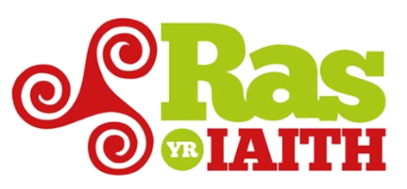 [Logo’r Fenter]

[Dyddiad]

Ras yr Iaith 2018 - Exciting News and Dates for your diary
Dear Headmaster/mistress, __________ School ,
In 2016 Ras yr Iaith was held for the second time, a non-competitive fun run for the Welsh language, visiting 22 villages / towns (between Bangor and Llandeilo), attracting more than 1000 participants and raising over £ 14,000 for local organisations supporting the Welsh language.
We are pleased to inform you that Ras yr Iaith returns on 4, 5 and 6 of July 2018, and by working closely with local organisations, including your local Menter Iaith / Welsh Language Enterprise, __________ we intend to expand and develop the Race / fun run by visiting and running in even more towns across Wales.

Ras yr Iaith will visit your area on ______ of July, we would like to invite your School pupils and staff to join us by taking part in the Race to celebrate Welsh, Welshness and the local community, and having lots of fun in the process.

The main aim is celebrating the language and showing pride in it, the Race also raises money to promote the Welsh language locally by inviting groups, clubs and local schools to sponsor a kilometer. In 2016 grants of over £ 14,000 were awarded to support local cases after the Race. We plan to raise even more money by expanding and developing the Race, and in order to keep the Race as open as possible the cost to sponsor each kilometer will remain the same as 2016, £50. For this your School will be able to run a km (or more) and there is no maximum number of pupils and teachers that can run.

We really hope that __________ School will join us this year, and share in the great experience of running to celebrate our language.
More information about the Race can be found on the website www.rasyriaith.wales. There is also information about the Race track and safety measures below. Please feel free to contact the Menter Iaith for more information or to register, and we look forward to working with you.

Sincerely,

Enw, Teitl, Menter, Ebost, Rhif ffôn

Security:
Stewards and Signs: Ras yr Iaith stewards will steward each clause wearing long sleeve ‘high-viz’ jackets. There will also be security signs to warn the public that the Race is taking place.
Supporting Vehicles: the Race will be led by a front vehicle that will ensure that the road is clear and safe. This is followed about 5 minutes later by the Race’s van. The runners will follow this vanand behind the runners will be the last vehicle of the Race to ensure that it’s safe at the back.
Insurance: there is an indemnity of up to £5m from the Race on the runners and stewards.
Runners: School teachers will need to run with the children. It must be emphasised although this is not a 'race' (everyone will run at a leisurely pace) but it is not possible for people to walk the clause. We suggest that the children running are of acceptable physical health - maybe they can practice for it as part of an exercise lessons.

