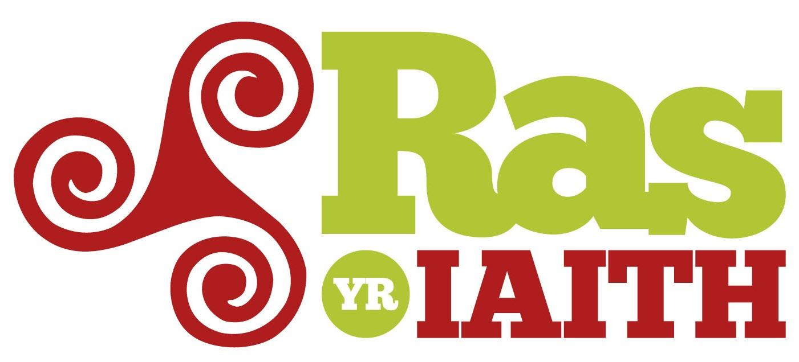

Ras yr Iaith
Mercher – Gwener, 4-6 Gorffennaf 2018 |
Wednesday – Friday, 4-6 July 2018

“Pasio’r baton a phasio’r iaith ymlaen!
Passing on the baton, passing on the language!”

Ras gyfnewid hwyl er mwyn yr iaith Gymraeg, ein cymunedau a’n hiechyd corfforol. 15 Tref dros 3 diwrnod, o Wrecsam i Gaerffili. Yn seiliedig ar rasus hwyl tebyg yn yr Iwerddon, Llydaw a Gwlad y Basg.

Fun relay run for the Welsh language, our communities and physical wellbeing. 15 town centres in three days; Wrexham to Caerphilly. Based on other successful language runs in Ireland, Brittany and the Basque Country.

Awduron | Authors
Heledd ap Gwynfor, Race coordinator, Mentrau Iaith Cymru Development Officer
Sion Jobbins, Race Manager, Rhedadeg cyf.
Iwan Hywel, Stewarding Manager, Mentrau Iaith Cymru

http://rasyriaith.cymru
www.twitter.com/rasyriaith
https://www.facebook.com/rasyriaith.cymru/

CYNNWYS | CONTENTS

Document A – Ras yr Iaith Management Document ………………………………………………3

Document B – Exceptional Circumstances Plan ………………………………………………….. 12

Document C – Manager & Local Head Stewards Details ……………………………………… 13

Document D – Support for Ras yr Iaith ……………………………………………………………….. 14

Document E – Detailed Race Plan, including signage information schedule + traffic management for:

Document F – Route Maps - pdf of maps including route, signage, steward locations

Appendix – Insurance, misc.

Ras yr Iaith – 4-6/7/2018
Ras yr Iaith Management Document (“Document A”)

Author:
Siôn T. Jobbins, Ras yr Iaith Manager Ras yr Iaith, 4 – 6 July 2018
Ras yr Iaith Management Document (“Document A”)
1 Ras yr Iaith
Ras yr Iaith is a relay fun run for the Welsh language over the course of three days commencing at Wrexham and finishing in Caerphilly. Runners of all ages and abilities will run through the centres of:
Day 1, Wednesday 4 July 2018
- Wrexham
- Menai Bridge
- Bangor
- Llanrwst
- Machynlleth
- Aberystwyth

Day 2, Thursday 5 July 2018

- Haverfordwest
- Carmarthen
- Ammanford
- Llanelli

Day 3, Friday 6 July 2018

- Ystradgynlais
- Pontardawe
- Clydach
- Porthcawl
- Caerphilly

This is not a competitive run – the intention is to bring together runners of all abilities in celebration of the Welsh language and bring the communities along the route closer together. It is based on successful language runs in Ireland, Brittany and the Basque Country.
Societies, businesses, schools and clubs are invited to sponsor a ‘stage’ of the run for £50. More than one person can run this stage and because of the short nature of the actual run more than one society can sponsor the same stage.
The Ras in each town is roughly around 1km-2km in length. It is important to note that every signposted km in this plan is not a strict metric km. Organisers have taken safety and suitability into account. The ‘km’ noted in the left hand column of the Detailed Race Plan is an indicator – ‘km’ can vary in length. Runners will be aware of this.
A specially commissioned baton will be passed on from one kilometre to the next. The baton will be transported by the Ras vehicles between the towns. There is no running between towns.
The event will be a fun, colourful and a musical affair. A specially commissioned song has been composed and performed and set to video by singer Dewi ‘Pws’ Morris. The song will be played along the route in the lead vehicle to motivate the runners and proclaim the event to passers-by, pedestrians and traffic.

2 Official Vehicles Details

Ras yr Iaith will be coordinated by two sets of vehicles. Vehicle 1 will be a lead by the Ras by some 10 minutes informing participants of the situation concerning the Ras and making sure stewards and runners are in place and informing Vehicles 2a and 2b of the on the ground situation.
The three vehicles in the diagram below are Vehicle 1, Vehicles 2a and 2b. All three vehicles will be designated with Ras yr Iaith livery.

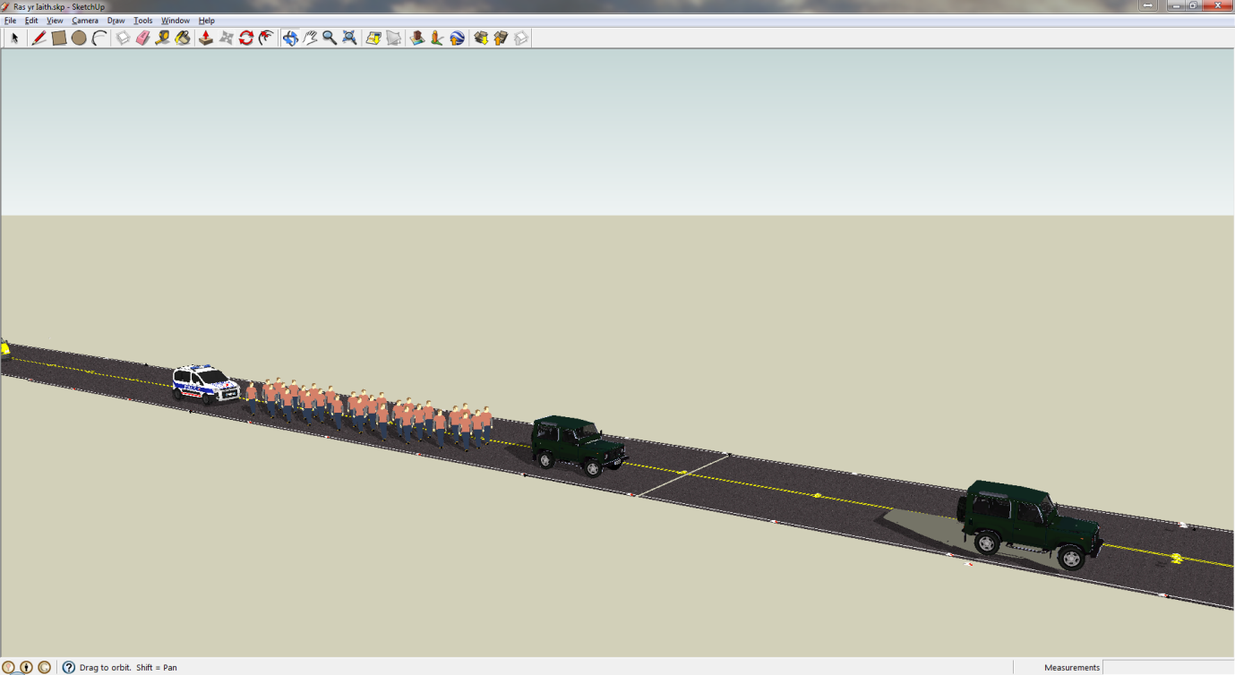

Vehicles 2a and 2b will be staffed with experienced drivers and race co-ordinators who have contributed to the event in 2014 and 2016, including volunteers who are members of Raynet. Raynet have a sterling track-record of supplying their services for community events as well as offering high quality services in times of emergency. They are offering this service free of charge to Ras yr Iaith in support of the ethos and stated aims of the run. Their website is: http://mid.cymru-raynet.org.uk/index.php/what-is-raynet
  - The Lead vehicle (Vehicle 1) will lead the Ras by some 5-10 minutes informing participants of the situation concerning the Ras and making sure stewards and runners are in place. It will consist of a driver and support member and will be in radio contact with Vehicles 2a and 2b of the situation.

  - Vehicle 2a will be the Ras’s main vehicle from the public’s point of view. It will carry the Ras logo, lights and signs promoting the Ras as well as loud-speaker for public announcements, words of encouragement for runners and also to relay the Ras’s specially commissioned song.

  - The Ras runners will be run between Vehicle 2a and 2b with a space of 3 meter either side. They will keep to within the width of the vehicles.

  - During the actual run vehicles 2a and 2b will travel at the same speed as the runners – approximately 7km per hour.

  - Vehicle 2b will follow the runners and will also carry the Ras logo, sponsor logos, lights but no loud-speaker with appropriate sign on the rear of the vehicle (Blue Background, White Arrow)

  - The Ras’s designated First Aid officer and first aid box will travel in Vehicle 2b. The designated first aider is a practising GP who is kindly volunteering again having done so in 2014 and 2016 also.

  - The Ras Manager will travel in Vehicle 2a throughout the event.

3 Stewarding Plan & Officers’ Responsibilities

Ras coordinator, Heledd ap Gwynfor, responsible for planning Race
↓
Ras Manager, Siôn Jobbins – travel in Vehicle 2a throughout the event (responsible for “In Race”, major decisions, such as abandonment/ cancellation during race)
↓
Stewarding Manager, (Iwan Hywel, Team leader, Mentrau Iaith Cymru) – Liaising and organising Local Head Stewards and attend stewards training prior to race. During race brief stewards before start of each stage, be in constant radio contact with vehicles.
↓
Local Head Stewards x 15 (Names TBC) – will have received training and located and responsible for their own town (Machynlleth etc.)
↓
Team of Local Stewards (Names TBC, refer to Document B) + Team of Local Running Stewards – will have been briefed by the Local Head Steward in a stewards meeting a week before the race and will meet up an hour before each stage for a final meeting before going to the allocated steward positions or being a running steward

Ras Manager’s Responsibility:
  - Coordinate the Ras from vehicle 2a
  - Responsible for the Ras during the event
  - Be in constant contact between the Head Local Stewards and Stewarding Manager
  - Take action in response or in anticipation of any development or unexpected risk in accordance with the Ras Management Plans.
  - Coordinate decisions with the event of any accidents, change of route, delay or cancel Ras if there is a serious risk to runners / public or officers.
  - Be in possession of Ras log of route, contact numbers for services, runners and Local Head Stewards

- Stewarding Manager’s Responsibility:

  - Attend relevant training courses
  - Liaise with Ras Manager on the Ras route and suitability for vehicles, runners, public with consideration for participant parking and waiting for baton changes
  - Make sure Local Head Stewards have received training – Training Schedule to be confirmed and included in final draft of plan
  - Prepare brief for Local Head Stewards and confirm that the brief is passed onto to Local Stewards
  - Make sure parking facilities are ear-marked and within reasonable and safe walking distance to the start/ finish.
  - Manage the stewarding of the event from the start point of each stage
  - Be the prime contact between the Local Head Stewards and Ras Manager
  - Act in the event of any development or risk in accordance with the Ras’s Exceptional Circumstances Plan(‘Document E’) e.g. reschedule and relocate Local Stewards, advise the Ras Manager and/or Local Head Stewards of any unexpected or exceptional events
  - Make sure ALL Stewards have long sleeved high viz vests (BSN Standard) which have been distributed to local stewarding teams
  - Contact phone numbers for Local Head Stewards
  - Make sure information is passed between the Ras Manager and Local Head Stewards

- Local Head Steward’s Responsibility:

  - Attend relevant training courses
  - Attend briefing meetings organised by the Stewarding Manager
  - Organise Team of Local Stewards and Local Running Stewards for the stage within their town
  - Make sure spaces are safe and suitable for the runners to start and finish
  - Make sure parking facilities are ear-marked and within reasonable and safe walking distance to the start/ finish
  - Organise briefing sessions for the Team of Local and Running Stewards in the weeks before the event (ALL stewards must attend and register at this briefing)
  - Confirm and be in possession of the contact details of all their Local and Running Stewards and share with the Steward Manager and Ras Manager.
  - Organise schedule and details for Local Stewards and Steward Runners e.g. meeting place and time, location of every Local Steward, route which every Local and Running Steward will be responsible for, precautions and plans in case of emergencies, communications plans
  - Be responsible for the safety of Local and Running Stewards and public
  - Make sure all Local and Running Stewards receive and wear hi-viz vests
  - Carry mobile phone at all time during the day of the event
  - Be fully aware of the information for their town leg e.g. street lay out, parking issues and locations etc.
  - Supervise the erection of Ras yr Iaith metal road signs; Ras yr Iaith street banners and Ras yr Iaith baton change placards and supervise their dismantling in accordance with the timetable listed below – Signage Plan (Document D) within Traffic Management Plan

Race Manager (in vehicle 2a), Stewarding Manager, Local Head Steward, Vehicle 1 and Vehicle 2b and some local stewards at key points of stages will have walkie talkies so will be in constant radio contact during stages.
- Local Steward:

  - Attend relevant training courses organised by Local Head Steward
  - Share information and contact details with Local Head Steward
  - Make sure to arrive at the designated meeting place on the day of the event at the designated time and inform Local Head Steward if there is any delay or issue
  - Make themselves aware of the Exceptional Circumstances Plan (Document E)
  - Wear hi-viz vest for the event
  - Carry mobile phone at all times on the day of the event
  - Be responsible for the safety of Local and Running Stewards and public
  - Be fully aware of of the information for their town leg e.g. street lay out, parking issues and locations etc.
  - Collect any rubbish created by the Ras and its runners and dismount the Ras yr Iaith A3 km placard after the runners have completed the stage

- Local Running Steward:

  - Attend relevant training courses organised by Local Head Steward
  - Share information and contact details with Local Head Steward
  - Be of good fitness level, the race moves at a “jogging pace”
  - Make sure to arrive at the designated meeting place on the day of the event at the designated time and inform Local Head Steward if there is any delay or issue
  - Make themselves aware of the Exceptional Circumstances plan
  - Wear hi-viz vest for the event as specified previously 4.10
  - Carry mobile phone at all times on the day of the event
  - Be responsible for the safety of Local and Running Stewards and public
  - Be fully aware of the information for their town leg e.g. street lay out, parking issues and locations etc.
  - Make sure runners keep within the width of the Ras yr Iaith vehicles and run safely and at a safe distance from the vehicles

8 Ras yr Iaith Runners
Ras yr Iaith has been launched so as to celebrate and promote the Welsh language by attracting occasional runners to participate. The Ras is open to children, young people, adults and runners of all abilities. We anticipate that over the whole course some 5,000 individuals will run a part of the course, refer to Document B for details. The Ras will run within the 15 towns only and the Race Baton will be transported by vehicle between those towns.
The Ras will run at a rate of approximately 7kmh, a rate comparable to the slowest participant. Clubs, societies, schools and business will pay £50 to sponsor a stage. If a runner or members of the society wish to run more than their stage they will need to inform the Ras organisers.
  - The sponsoring club/society/individuals will be responsible for making their own plans to arrive and depart and park from the designated start/ finnish locations.
  - The Runners will know and utilise the parking/drop-off/collect as designate by the Ras yr Iaith Organisers
  - The runners will be made aware of the route including the risks and health and safety issues by the Local Head Steward (see Document B)
Runner Registration
  - Every sponsoring club/school/business will need to register by filling in the Registration Form. The form will ask for the number of runners, contact name and number for the main contact and note any special needs e.g. wheelchair participants
  - All organisations (or main contact – teacher, club chairman etc) taking part in a stage of the Ras will attend a briefing meeting organised by the Local Head Steward in the weeks before the event where the details will be explained – route, health and safety, schedule etc. If they cannot attend this meeting the Local Head Steward must ensure they have given and explained all relevant details to a nominated person of each organization's prior to race day.
  - The Local Head Steward will also inform the runners of the main contact numbers for the Ras organisers – Local Main Steward, Ras Manager, Steward Manager
  - The safety of the route will be assessed for Risks (see Document B) and all Runners will be expected to adopt safe practice and respond to the Stewards’ instructions at all times.

9 Ras yr Iaith 2018 Organisers
For the 2018 Ras, Rhedadeg Cyf, the not-for-profit company which is legally responsible for the Ras, has cooperated with the various Mentrau Iaith in the different counties (see www.mentrauiaith.cymru) and with Mentrau Iaith Cymru nationally. The Mentrau have a long tradition and experience of organising events in their localities (such as St Davids day parades and music festivals) and know the area, personnel and various emergency services well in their locality. They can also call upon a wide cross-section of the local community to help organise and facilitate an exciting and challenging event like Ras yr Iaith.

10 Accidents / Emergency Plans / First Aid
The Ras Manager and Stewarding Manager will prepare a designated brief and guideline for participants and stewards to use in the event of an accident or unexpected event. This will be explained as part of the Training Course for the Main Local Stewards and Local Stewards and Local Running Stewards.
Trained medics and First Aid equipment will travel in Ras Vehicle 2b throughout the Ras (a practicing GP)
The Ras organisers will inform the Local Health Authority of the event.

11 Weather Contingency Plan
Ras yr Iaith will be held on 4 - 6 July. The date was chosen in part because of the presumed favourable weather and sunlight conditions. However, in the event of exceptional circumstances, e.g. extreme wet weather (heavy rain, flooding) or major incident the Ras organisers (Ras Manager and Stewarding Manager,) will consider postponing the event and act in accordance with the Ras Exceptional Circumstances Plan (Document C) and will immediately inform all personnel and participants as per plan.
In the case of exceptional hot weather the Ras organisers will inform the runners of the need to wear suitable clothing and drink enough fluids. The Ras vehicles will also carry a supply of water.
In the case of extreme or unexpected weather the Ras Manager will react and act to the situation.
12 Insurance

Ras yr Iaith has organised and paid for public insurance worth £5m with Tennyson Insurance who are a subsidiary of Zurich Insurance. The insurance’s policy number is: XAO 1220639303

We attach a copy of the Insurance.

13 Traffic Management Plan

See Detailed Race Plans 1-9 which include:
Leg / Route Detail
Risk Assessment + Mitigation (Document B)
Detailed Map including Steward numbers and location (Document C)
Signing Schedule – including location. (Document D)
See Also Exceptional Circumstances Plan (Document E)
Information about the Ras route will be placed online on the Ras’s website www.rasyriaith.org and www.mentrauiaith.cymru other relevant authority websites.
The Ras will also widely promote and inform the driving public of the event’s route and schedule through banners, signage, advertising, AA road-watch, Traffic Wales and other media.
Ras yr Iaith will contact local bus contractors to inform them of the event.
Contact Details:
Sion Jobbins, Ras Manager, 07815 85 78 21

Iwan Hywel, Stewarding Manager, 07811941044

Heledd ap Gwynfor, Ras coordinator 07813 604390

Mentrau Iaith Cymru Head office, Llanrwst: 01492 643401

Amublance, NHS Ambulance, Mid and West Wales Service: 01792 562900

Wrexham Maelor Hospital: 01978 291100

Ysbyty Gwynedd, Bangor: 01248 384384

Bronglais Hosptial, Aberystwyth: 01970 623131

Glangwili Hospital, Carmarthen: 01267 235151

Prince Phillip Hospital, Llanelli 01554 756567

Princess of Wales Hospital, Bridgend 01656 752752

Morriston Hospital 01792 702222

Heath Hospital, Cardiff 02920 747747

Document B – RAS YR IAITH
Exceptional Circumstances & Severe Weather Plan
Weather forecasts are tracked before the race for heavy rain, thunder and lightning, high winds and extreme heat. If there is a possibility of threatening weather, information will be posted on the Ras yr Iaith web site so that runners can prepare for severe weather during the race as well as possible course changes.
On the day of the race, Ras yr Iaith Manager will decide if any changes will be made to the race. The race start time can change, the race can be postponed or the event can be cancelled.
Lightning – If lightning is closer than 6 miles away, the race will be postponed by 30 minutes. If the lightning continues to be within 6 miles after a period of 30 minutes, the race will be cancelled.
In case of extreme high temperatures (above around 28C), or extreme rain or/ and high wind, resulting in dangerous conditions, Ras yr Iaith Manager will cancel the event and relay information to the Stewarding Manager who will contact all Local Head Stewards to notify all involved.
Ras yr Iaith Manager will notify Stewarding Manager of any decisions to delay or cancel the event, the Stewarding Manager will contact all Local Head Stewards by mobile phone to relay the information to all other Stewards and Participants.
In the event of a Major Incident, e.g. RTA, Road Closure or Safety Threat – the Ras yr Iaith Manager will assess the impact of the situation and act accordingly, for example:
Road Closure due to RTA – RyI Manager to decide whether a stage can start/ continue along an alternative route within a town or cancel the leg and move on to the next leg of the Ras if road access and safety is guaranteed.
RyI Manager will notify Stewarding Manager who will notify all other Stewards of decision to adapt route, cancel or skip a particular stage of the route. Local Stewards will notify participants and general public/supporters.
Ras yr Iaith Manager: Siôn Jobbins
Stewarding Manager: Iwan Hywel
Local Head Stewards: Document C
Local Stewards: To be recruited locally

Document C – RAS YR IAITH Stewarding
Ras yr Iaith Manager
Siôn Jobbins. Former elected councillor, mayor of Aberystwyth, former head of Communications Unit at the National Library of Wales; leader of bid for .cymru internet domain; founder of Aberystwyth St David’s Day Parade. Siôn wrote a commissioned report for the Welsh Language Board, financed by the NPLD (www.npld.eu) on similar language runs in the Basque Country, Brittany and Ireland and has visited and participated at those runs. sion.jobbins@gmail.com | 07815 85 78 21
Sion organised the 2014 event and co-organised the 2016 event with Mentrau Iaith Cymru
Stewarding Manager
Iwan Hywel: Team leader, Mentrau Iaith Cymru with Mentrau Iaith Cymru. Co-organised the race in 2016, CHAPTER 8 trained.
iwanhywel@mentrauiaith.cymru | 01492 643401/ 07811 941044.
Local Head Stewards
These will be Mentrau Iaith staff (To be confirmed by 30th of May 2018)

Document D – RAS YR IAITH Support
Community Support
The Ras has been in close cooperation with community organisatins and national institutions such as: Urdd, Cymraeg i Oedolion (Welsh for Adults); Tinopolis; Aberystwyth University and third sector groups. Through the Mentrau Iaith the Ras has had the support of a wide network of groups, businesses and clubs.

Community Council Support
Ras yr Iaith has contacted and informed town and community councils along the route of the event.
Many community councils have agreed to sponsor the event as a sign of their support for the venture.

County Council and Police Support
For the first Ras in 2014, the organisers worked in close cooperation with both the Road Closure Section of Ceredigion County Council (which has acted as lead authority with Powys, Carmarthenshire and Pembrokeshire) and Dyfed Powys Police (Chief Inspector Nicola Carter and Inspector Aled Davies). Suggestions by both parties have been incorporated into this document.
The 2016 Ras has had active advice and support from Bob Price, Force Planning and Civil Contingencies Specialist at Dyfed Powys Police, 01267 248455 and Andrew McGregory of North Wales Police.
The Ras has been and will be in constant contact with county council officers.
Major Sponsors:
BT- Main Sponsor
Brecon Carreg
Tinopolis
Gwent Police and Crime Commissioner
Dyfed Powys Police and Crime Commissioner
Golwg
Aberystwyth University

*End*

