**BETHESDA – 11:00 – 11:45, dydd Mercher 06/07/2016**

**Cymal 2 / Leg 2**

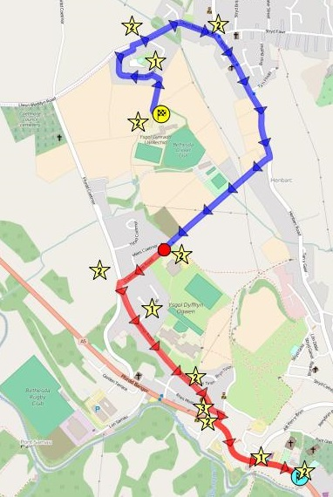

**Rhan 1 / Part 1 = 2.5km**

**Rhan 2 / Part 2 = 1.9km**

** Stiward “CH 8”- x3**

**CYFANSWM = 4.4km**

Stiward / Stewards****