Yr Iaith Gymraeg – Cwis / Quiz
- Pasiwyd y Deddfau Uno gan Edward II. Erbyn 1536 yr oedd Cymru, o ran y gyfraith yn rhan o Loegr, a Saesneg oedd unig iaith swyddogol y wlad.
Edward II passed the Acts of Union, joining England and Wales. By 1536, Wales by law was part of England and English was the only official language in the country.
True or False? __________________________________________________________

- 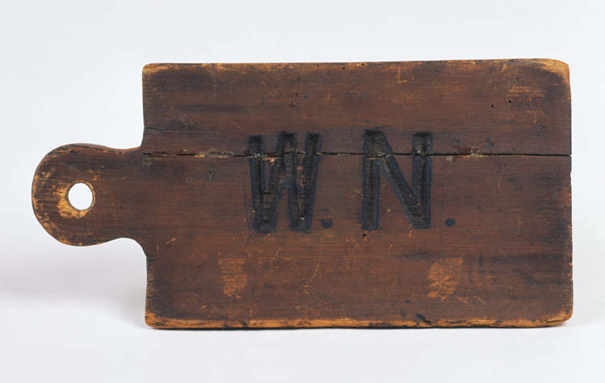
Defnyddiwyd y 'Welsh Not‘ yn y ddeunawfed ganrif a'r bedwaredd ganrif ar bymtheg, mewn ymgais i rwystro plant rhag siarad Cymraeg. Darn o bren neu lechen fechan oedd y 'Welsh Not', a'r llythrennau 'W.N.' wedi eu torri arno. Byddai'r 'Welsh Not' yn cael ei grogi o amgylch gwddf unrhyw blentyn a fyddai'n cael ei ddal yn siarad Cymraeg. Byddai'r athro yn cosbi'r plentyn a fyddai'n ei wisgo ar ddiwedd y dydd.
The 'Welsh Not' was used during the eighteenth and nineteenth century in a bid to prevent pupils from speaking Welsh. It usually consisted of a small piece of wood or slate inscribed with the letters 'W.N‘. It was hung around the neck of a child who was caught speaking Welsh. At the end of the school day, the child wearing the 'Welsh Not' would be punished by the schoolteacher.
True or False? __________________________________________________________

- Yn 1900 nid oedd gennych chi’r hawl i gael addysg trwy gyfrwng y Gymraeg, nac ychwaith hawl i gael treial trwy’r Gymraeg neu i dderbyn gohebiaeth swyddogol trwy’r Gymraeg.

In 1900 you had no right to study through the medium of Welsh, no right to a trial in Welsh nor the right to receive official documentation in Welsh.

True or False? __________________________________________________________

- Yn 1982 ffurffwyd Cymdeithas Yr Iaith Gymraeg i frwydro dros hawliau i’r iaith Gymraeg.
Cymdeithas Yr Iaith Gymraeg (The Welsh Language Society) was formed in 1982 to fight for rights for the Welsh Language.

True or False? __________________________________________________________

- Ar ôl cannoedd o flynyddoedd o addysg trwy’r Saesneg, agorwyd y 2 ysgol uwchradd cyfrwng Gymraeg gyntaf yn Nghymru yn Ngwynedd.
After hundreds of years of English medium education, the first Welsh-medium secondary schools in Wales opened in the county of Gwynedd.
True or False? __________________________________________________________

- Yn ôl Deddf yr Iaith Gymraeg 1967 + 1993 mae Cyrff Cyhoeddus bellach yn gorfod darparu gwasanaethau drwy’r Gymraeg.
According to the 1967 + 1993 Welsh Language Acts, Public Bodies now have to provide their services through the medium of Welsh.
- Am y tro cyntaf erioed, rhoddodd censwn 2011 y cyfle i bobl mynegi ei hunananiaeth fel ‘Cymraeg’.

For the first time ever in British census history the 2011 Census gave the opportunity for people to describe their identity as Welsh.

True or False? __________________________________________________________

8 . Mae yna 50,000 o bobl yn byw ynghanol Llundain sy’n deall yr iaith Gymraeg.
There are approximately 50,000 people who understand Welsh living in the greater London area.
True or False? __________________________________________________________

9. Mae yna gwladfa Cymraeg ym Mrazil lle mae’r iaith Gymraeg yn cael ei siarad.
There is a Welsh colony in Brazil where the Welsh language is widely spoken.
True or False? __________________________________________________________

